Global Biosimilars Week Social Media Calendar 2021
2021 marks the 15-year anniversary since the European Medicines Agency's approval of the first biosimilar.

To honour this anniversary and acknowledge the important role of biosimilars within cancer treatment in transforming the outlook for cancer
patients, join this year’s conversation about biosimilars, taking place in November. Help spread awareness and educate patients about biosimilars!
Check the GlobalBiosimilarsWeek website regularly for more details about the 2021 campaign: https://www.globalbiosimilarsweek.org/2021

What is the social media calendar?

This social media plan has been designed for DiCE members with the aim to actively take part in the Global Biosimilars Week (November 1-5, 2021) through daily posts. The pre-made posts are designed to make posting as quick and easy as possible for you. More information on effective social media use can be found in the DiCE Social Media Toolkit.

What are the general guidelines?

There are three posts for each day of Global Biosimilars Week: one for each social media platform (Twitter, Facebook, and LinkedIn). Each day’s posts have a similar underlying theme but are adapted to the specific platform. It is encouraged to set aside time each day to post – we recommend setting a routine of posting in the morning so that users can engage throughout the day. The pre-made posts already include relevant hashtags; however, if you post additional content or adapt the provided content, please always include #GlobalBiosimilarsWeek in addition to any hashtags you prefer. We propose #BiosimilarEducation and/or #biosimilarmedicines.

How can I do more?

If you want to go further than the three daily posts, there are a few options:
- DiCE along with the organisers of Global Biosimilars Week and other relevant stakeholders will be posting all week – you can retweet, share, comment on, and like their content to help increase awareness and visibility of posts.

Twitter Captions |  |  | Facebook Caption | LinkedIn Caption | Visual
Date & theme | 1/11: Today’s Biosimilars Landscape
Have you heard? It’s #GlobalBiosimilarsWeek! The first EMA #biosimilar was approved 15 years ago; we now have >70 #ECapproved biosimilars making #biologicaltreatments more #accessible & #affordable 💊 💉 @EMA_News  Read more on our FAQ sheet: [Link to be included] |  |  | Have you heard? It’s #GlobalBiosimilarsWeek! The first European Medicines Agency #biosimilar was approved 15 years ago; we now have over 70 EC-approved biosimilars & 2 billion patient treatment days of positive experience with biosimilar use. Biosimilars make biological treatments more accessible and affordable!  Biosimilars are as safe and effective and of the same high quality as their originators (also known as reference products) but barriers still exist in their acceptance.  Do you have any questions about biosimilars? Check out our FAQs [Link to be included] or leave them in the comments below and we’ll answer them. We will also post more information throughout the week! | Have you heard? It’s #GlobalBiosimilarsWeek! The first European Medicines Agency #biosimilar was approved 15 years ago in the EEC; we now have over 70 EC-approved biosimilars & 2 billion patient treatment days of positive experience with biosimilar use. Biosimilars make biological treatments more accessible and affordable! Biosimilars are as safe and effective and of the same high quality as their originators (also known as reference products) but barriers still exist in their acceptance.  In fact, they comply with all the same regulatory requirements, and contribute to increased access to care.  For more information, we created a comprehensive position paper on the use of biosimilars: https://digestivecancers.eu/wp-content/uploads/2020/02/468-Document-Positionpaperbiosimilarsfinal.pdf  and a great FAQ:  [Link to be included]  Stay tuned: we’ll be posting more information about biosimilars all week! | 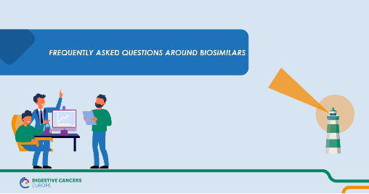
Date & theme | 2/11: The Biosimilars Road Ahead
Making sure patients understand their treatment options is a priority for us. To support doctor-patient communication on #switching and #SharedDecisionMaking, watch our video. #GlobalBiosimilarsWeek #BiosimilarEducation @medicinesforEU @moss_barbara  [Link to be included] |  |  | Did you know? Biosimilars can be used to treat metastatic colorectal cancer.  Making sure patients understand their treatment options is a priority for us. Simple and clear communication about #biosimilars is key for their acceptance. Discussions about #switching need to be open and inspire confidence in the patient. This can prevent the ‘nocebo’ effect, optimizing treatment outcomes.  For this, we have produced a video to support doctor-patient communication on switching and shared decision-making.  #GlobalBiosimilarsWeek #BiosimilarEducation  [Link to be included] | Did you know? Biosimilars can be used to treat metastatic colorectal cancer  Making sure patients understand their treatment options is a priority for us. Simple and clear communication about #biosimilars is key for their acceptance. Discussions about #switching need to be open and inspire confidence in the patient. This can prevent the ‘nocebo’ effect, optimizing treatment outcomes.  For this, we have produced a video to support doctor-patient communication on switching and shared decision-making.  #GlobalBiosimilarsWeek #BiosimilarEducation @medicinesforEU @moss_barbara  [Link to be included] | 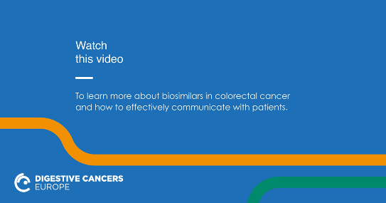
Date & theme |  | 3/11: Biosimilars and Patient Benefits
Patients should always have access to trustworthy information on their treatment options, including #biosimilars. Read our brochure for patients with colorectal cancer:  #GlobalBiosimilarsWeek  #BiosimilarEducation @yannickvdp @EuColonPolska @Jdmunter1 @moss_barbara  [Link to the brochure to be included] |  |  | We advocate for clear, reliable and easy-to-understand information for patients.  Patients should always have access to trustworthy information on their treatment options, including #biosimilars. This is why we created a brochure for patients with colorectal cancer.  [Link to the brochure to be included]  Our brochure was created in collaboration with our expert working group on biosimilars in a language easy to understand.  Learn more about the group here: https://bit.ly/3ARgBvf  If you have any additional questions, you can reach out to us or post in the comments below. #GlobalBiosimilarsWeek #BiosimilarEducation | We advocate for clear, reliable and easy-to-understand information for patients.  Patients should always have access to trustworthy information on their treatment options, including #biosimilars. This is why we created a brochure for patients with colorectal cancer.  [Link to the brochure to be included]  Our brochure was created in collaboration with our expert working group on biosimilars in a language easy to understand.  Learn more about the group here: https://digestivecancers.eu/campaigning-and-education/biosimilar-education-in-metastatic-colorectal-cancer/  Sharing reliable educational and communication tools for #patients is crucial for spreading awareness!  If you have any additional questions, you can reach out to us or post in the comments below. #GlobalBiosimilarsWeek #BiosimilarEducation  @moss_barbara @johan de munter  @yannick-vandenplas  @Fundacja EuropaColon Polska | 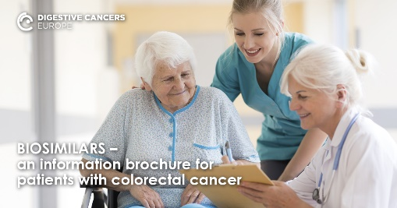
Date & theme | 4/11: Building a Better Future with Biosimilars
What is the value of #biosimilars for patients? They increase #access to biological treatments and reduce patients’ waiting time to be treated. To learn more, watch our event on biosimilars.  #GlobalBiosimilarsWeek #BiosimilarEducation @moss_barbara @DolorsMM @RosGiuliani @yannickvdp @EU_Commission  @Europarl_EN @EUCouncil  @EU_ENV  https://bit.ly/3GkR6GM |  |  | Wondering what the value of #biosimilars is for patients? They can increase access to biological treatments, reduce patients’ waiting times to be treated and fund new, innovative treatments.  Watch our recent policy event discussing the opportunities offered by biosimilar medicines: https://bit.ly/3GkR6GM  #GlobalBiosimilarsWeek #BiosimilarEducation | Wondering what the value of #biosimilars is for patients? They can increase access to biological treatments, reduce patients’ waiting times to treatment and fund new, innovative treatments.  To maximise these opportunities, patients and policymakers need to be informed.  Watch our recent policy event discussing the opportunities offered by biosimilar medicines: https://www.youtube.com/watch?v=8Cgis-ChEoE  #GlobalBiosimilarsWeek #BiosimilarEducation  @moss_barbara @yannick-vandenplas  @Dolors Montserrat | 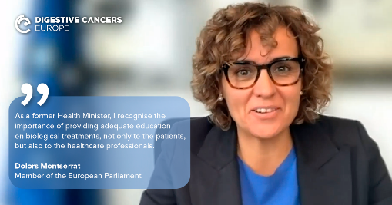
Date & theme | 5/11: Join the Biosimilars Movement!
It’s the last day of #GlobalBiosimilarsWeek Check out our #CallToAction, calling on the @EU_Commission, @EUCouncil @Europarl_EN  and other stakeholders to take action to improve the use of #biosimilarmedicines in #ColorectalCancer  https://bit.ly/2Z5ztcZ  #BiosimilarEducation #PharmaceuticalStrategy  @EMA_News @myESMO  @EU_ENV @cancernurseEU |  |  | It’s the last day of #GlobalBiosimilarsWeek – thanks for tuning in all week!  To stay involved, keep following our posts, share your new knowledge, and help us overcome the barriers to biosimilar acceptance! You can also read, share and endorse our Call to Action, calling on the European Commission, EU Member States and other stakeholders to take action to improve the use of #biosimilar medicines in colorectal cancer through adapting EU policies.  Let’s make biosimilars common knowledge through education, communication and policy actions.  #BiosimilarEducation #PharmaceuticalStrategy  https://bit.ly/2Z5ztcZ | It’s the last day of #GlobalBiosimilarsWeek – thanks for tuning in all week!  To stay involved, keep following our posts, share your new knowledge, and help us overcome the barriers to biosimilar acceptance! You can also read and share our Call to Action, calling on the European Commission, EU Member States and other stakeholders to take action to improve the use of biosimilar medicines in colorectal cancer through adapting EU policies.  Let’s make biosimilars common knowledge through education, communication and policy actions, as well as open, transparent information-sharing.  We’re always here as a resource for you!  #BiosimilarEducation #PharmaceuticalStrategy  https://digestivecancers.eu/wp-content/uploads/2021/09/DiCE_BiosimilarsEvent_Call-to-Action.pdf  @ESMO @European Commission @Dolors Montserrat @european-oncology-nursing-society-eons  @european-medicines-agency/ | 