#GastricCancerAwarenessMonth Social Media Calendar

Thank you for taking part in this year’s #GastricCancerAwarenessMonth campaign. For the month of November, we will be posting the following on Twitter, Facebook and LinkedIn. We invite you to follow, like, share, retweet our posts or create your own from the suggested texts below.

If you would like to translate the texts on the images, we have also provided you with blank templates. If this is the case for your organisation, we ask you to please keep:
- Using our font Century Gothic
- The Digestive Cancers Europe logo on the images, adding your organisation’s logo in white alongside this in the green border. This is important due to our ownership rights on the images.

If you need an easy-to-use application for updating the images, ‘Canva Pro’ is available free of charge for all NGOs and hence all our Members.
All images with and without texts are available here: https://bit.ly/3DjLp9B
Should you have any questions on how to access the calendar or how to use Canva Pro, please contact catie@digestivecancers.eu.
Thanks again and we look forward to working on this important topic for European gastric cancer patients together with you!

DATE | Twitter Captions | Facebook/LinkedIn Captions | Visual
31/10 | #GastricCancerAwarenessMonth starts tomorrow! Help us raise awareness by keeping up with us, sharing or using our social media calendar: bit.ly/3ljNnRd | Did you know that November is #GastricCancerAwarenessMonth and it starts tomorrow? We invite you to join us for the next 30 days in raising awareness on this lesser-known and difficult to treat cancer that costs ≈97.000 European lives a year.  To do this we’ve produced a social media calendar to help you create your own posts. You can alternatively follow and like our posts throughout the month – thank you in advance! bit.ly/3ljNnRd | 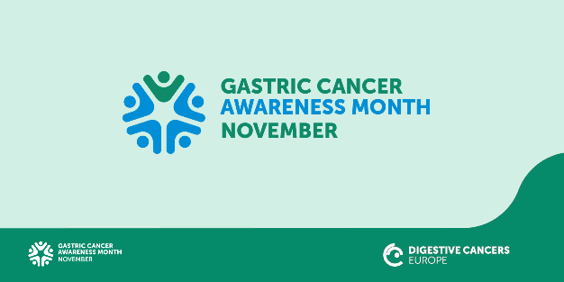
1/11 | Did you know that in Europe, around 136.000 people are diagnosed with #GastricCancer each year? We advocate for prevention and health promotion to reduce incidence. #GastricCancerAwarenessMonth Read more: bit.ly/3m2nbtB | Did you know that in Europe, around 136.000 people are diagnosed with #GastricCancer each year?  We advocate for prevention and health promotion to reduce incidence.  Help us raise awareness for #GastricCancer during #GastricCancerAwarenessMonth – like and share this post or create your own using our already prepared materials.  You can find them here: bit.ly/3ljNnRd | 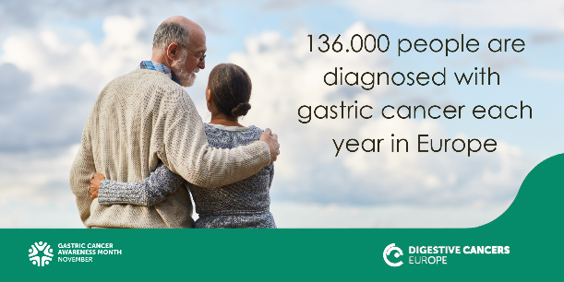
2/11 | #GastricCancer is the sixth most common cause of cancer-related death in Europe. Symptom awareness and early detection can reduce the mortality rate. #GastricCancerAwarenessMonth  Read more: bit.ly/3CNi7A2 | #GastricCancer is the sixth most common cause of cancer-related death in Europe. For #GastricCancerAwarenessMonth we’re sharing a daily fact to help increase symptom awareness for early detection of this lesser-known and difficult to treat cancer. By doing this we can save lives.  Please share further and help us in our efforts! Read more: bit.ly/3CNi7A2 | 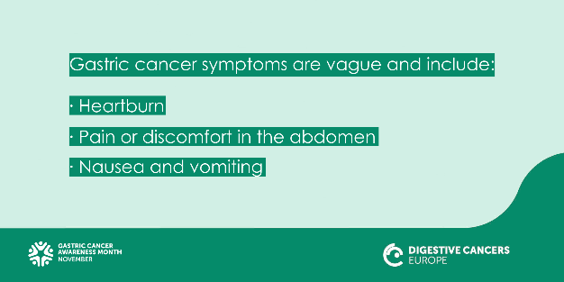
3/11 | Did you know that each year ≈97.000 European citizens lose their lives to #GastricCancer? It’s high time we raise awareness and apply effective preventive measures. #GastricCancerAwarenessMonth Read more: bit.ly/3m2nbtB | Did you know that each year ≈97.000 European citizens lose their lives to #GastricCancer? It’s high time we raise awareness and apply effective preventive measures. #GastricCancerAwarenessMonth  Read more in our Roadmap: bit.ly/3m2nbtB | 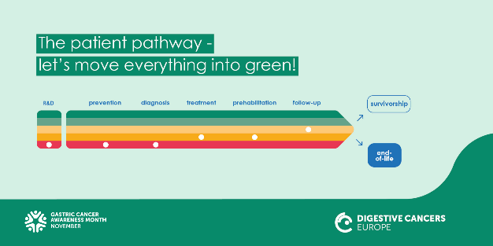
4/11 | #CancerFact: Did you know that  #Hpylori bacterial infection is a major cause of #GastricCancer?  Read more: bit.ly/39CBzmC #GastricCancerAwarenessMonth | It’s daily fact time for #GastricCancerAwarenessMonth!  Did you know that  #Hpylori bacterial infection is a major cause of #GastricCancer?  Find out more about the risks of this lesser-known and difficult to treat cancer on our website: bit.ly/39CBzmC  Please share this fact further and help us raise awareness! | 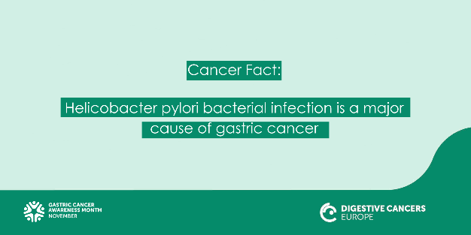
5/11 | Timely and accurate diagnosis of #GastricCancer requires systematic referral to #multidisciplinary  expert centres. Read our top-line recommendations in our Roadmap: bit.ly/3m2nbtB #GastricCancerAwarenessMonth | It’s #GastricCancerAwarenessMonth – in our publication ‘The European Oesophageal and Gastric Cancers Roadmap’ we set out a path for better care, treatment and outcomes for people living with this lesser-known and difficult to treat cancer.  Our recommendations include the timely and accurate diagnosis of #GastricCancer requiring systematic referral to #multidisciplinary  expert centres. Discover the Roadmap and all our recommendations to help save lives: bit.ly/3m2nbtB | 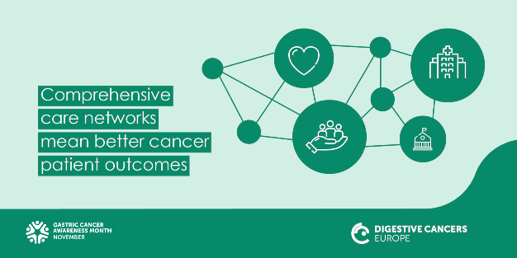
8/11 | Surveillance of patients with  precancerous lesions can prevent #GastricCancer #secondaryprevention  #GastricCancerAwarenessMonth - spread the word. Find out more: bit.ly/2WefCqL | Did you know that each year ≈97.000 European citizens lose their lives to #GastricCancer?  Studies show surveillance of patients with  precancerous lesions can prevent #GastricCancer highlighting the importance of #secondaryprevention.  It’s high time we raise awareness and apply effective preventive measures. #GastricCancerAwarenessMonth  Read more: bit.ly/3m2nbtB | 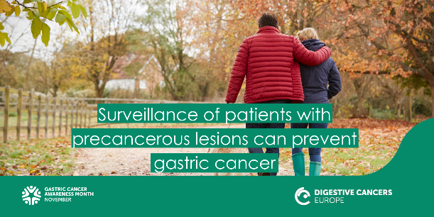
9/11 | Did you know that the support of a specialist dietitian before, during and after #GastricCancer treatment can improve patients’ #QoL? Read more about the importance of nutritional assessment before, during and after treatment: bit.ly/3m2nbtB #GastricCancerAwarenessMonth | Did you know that the support of a specialist dietitian before, during and after #GastricCancer treatment can improve patients’ quality of life?  Read more about the importance of nutritional assessment before, during and after treatment: bit.ly/3m2nbtB.  Please share this fact further and helps us raise awareness for people living with gastric cancer! | 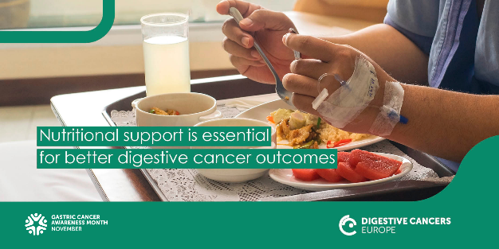
10/11 | Smoking, being overweight and diets high in salted meat and smoked foods are risk factors associated with #GastricCancer. Implementing healthy habits may prevent this hard-to-treat cancer. #GastricCancerAwarenessMonth bit.ly/39CBzmC | It’s daily fact time for #GastricCancerAwarenessMonth!  Smoking, being overweight and diets high in salted meat and smoked foods are risk factors associated with #GastricCancer.  Implementing healthy habits may prevent this hard-to-treat cancer. Read more: bit.ly/39CBzmC  Please share our daily fact and help raise awareness on this type of digestive cancer! #Sharingiscaring for patients. | 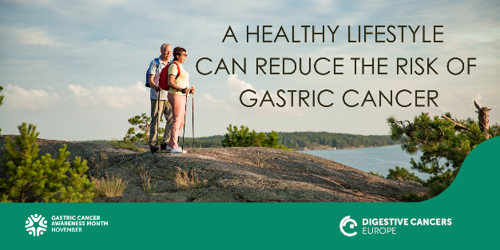
11/11 | What is #GastricCancer? It is cancer that generally begins in the cells lining the mucosal layer of the #stomach and spreads through the outer layers as it grows. Learn more: bit.ly/2WefCqL #GastricCancerAwarenessMonth | Do you know what #GastricCancer is?  It’s cancer that generally begins in the cells lining the mucosal layer of the #stomach and spreads through the outer layers as it grows.  Learn more on our website: bit.ly/2WefCqL  Share our daily fact and help save lives for #GastricCancerAwarenessMonth
12/11 | #GastricCancer #symptoms are vague and include heartburn, pain or discomfort in the abdomen, nausea and vomiting. Don’t ignore them! Visit your family doctor. Find out more: bit.ly/3CNi7A2 #GastricCancerAwarenessMonth | Know your #GastricCancer symptoms:  They are vague and might include:  - Heartburn  - Pain or discomfort in the abdomen  - Nausea and vomiting  If you, or someone you know, has any of these symptoms, don’t ignore them! We recommend you visit your family doctor to get a medical opinion.  Find out more: bit.ly/3CNi7A2  Please share this further for #GastricCancerAwarenessMonth #sharingiscaring
15/11 | We call for an improvement in the patient pathway of patients with #GastricCancer. Europe needs to understand & act upon patients’ unmet needs now! bit.ly/3m2nbtB  #GastricCancerAwarenessMonth | We call for an improvement in the patient pathway of patients with #GastricCancer. Europe needs to understand & act upon patients’ unmet needs now!  Read more about how to make this possible in our publication ‘The European Oesophageal and Gastric Cancers Roadmap’: bit.ly/3m2nbtB  #GastricCancerAwarenessMonth
16/11 | Did you know that the economic burden of #GastricCancer is ≈€5 billion each year in Europe, of which ≈€3.1 billion relates to indirect costs? Discover this and other key facts here: bit.ly/3ofPOX6 #GastricCancerAwarenessMonth | Did you know that the economic burden of #GastricCancer is ≈€5 billion each year in Europe, of which ≈€3.1 billion relates to indirect costs?  Discover this and other key facts that can help decision makers make better budgetary decisions in healthcare here: bit.ly/3ofPOX6  #GastricCancerAwarenessMonth – please share the facts and help save lives! | 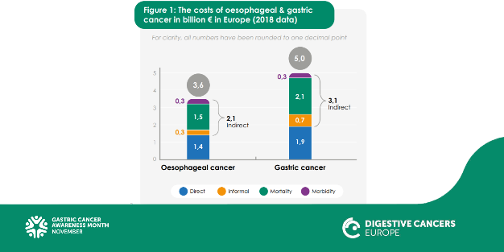
17/11 | #GastricCancer is often detected at late stages when it is more difficult to treat. Together let’s raise primary care physician awareness about symptoms to achieve early detection. Read more: bit.ly/3m2nbtB #GastricCancerAwarenessMonth | Did you know that #GastricCancer is often detected at late stages when it is more difficult to treat?  Together let’s raise primary care physician awareness about symptoms to achieve early detection.  Read more about how to make this possible in our publication ‘The European Oesophageal and Gastric Cancers Roadmap’: bit.ly/3m2nbtB  #GastricCancerAwarenessMonth | 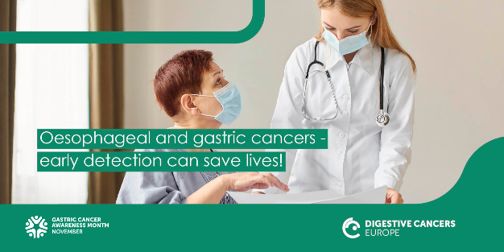
18/11 | Did you know that in ≈20% of metastatic #GastricCancer patients the #biomarker #HER2 is overexpressed? Timely biomarker testing can allow access to optimal treatment. #precisionmedicine  #GastricCancerAwarenessMonth | Our daily #GastricCancerAwarenessMonth fact:  Did you know that ≈20% of metastatic #GastricCancer patients have a biomarker - HER2+ - that decides on their treatment? We want all those patients to have timely biomarker testing to allow access to optimal treatment.  Like, share and follow our posts – increase awareness and help save lives! | 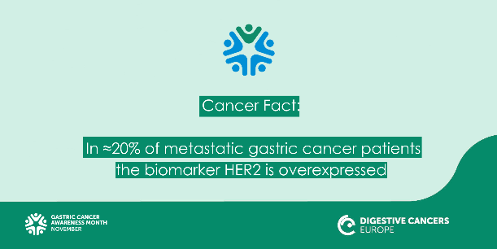
19/11 | Patients with #GastricCancer ask for nutritionists, psychologists and other patients to talk to. Facts from our patient survey: bit.ly/3FpOtmz #GastricCancerAwarenessMonth | What do #GastricCancer Patients ask for often?  Nutritionists, psychologists and other patients to talk to.  Important facts gathered from our Gastric Cancer patient survey: bit.ly/3FpOtmz  #GastricCancerAwarenessMonth – please share the facts and help save lives! | 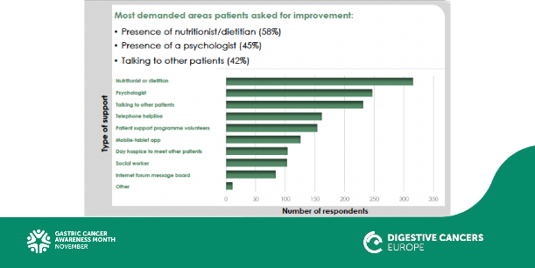
20/11 | If you have a family member with #GastricCancer, let your family doctor know. Some inherited mutations predispose individuals to developing gastric cancer. #CDH1 Watch how genetic testing saved Maria’s life: bit.ly/2Y5Xtwv #GastricCancerAwarenessMonth | Do you have a family member with #GastricCancer?  If yes, let your family doctor know. Some inherited mutations predispose individuals to developing gastric cancer. #CDH1  Watch how genetic testing saved Maria’s life: bit.ly/2Y5Xtwv #GastricCancerAwarenessMonth  Learn about the science behind.  Hear Carla Oliveira talk about genetic hereditary gastric cancer syndromes at our Masterclass: bit.ly/2YgYsK5 | 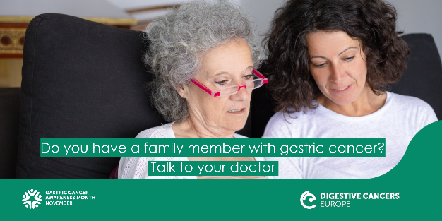
22/11 | Our survey of patients with #GastricCancer or oesophageal cancer showed that 65% of patients were not satisfied with the emotional support their family members received. We advocate for better #CareForCarers bit.ly/3FpOtmz | It’s #GastricCancerAwarenessMonth.  Our survey of patients with #GastricCancer or oesophageal cancer showed that the 65% of patients were not very satisfied or very dissatisfied with the emotional support their family members received.  Cares have an important role for #GastricCancer patients, and they also need support. bit.ly/3FpOtmz | 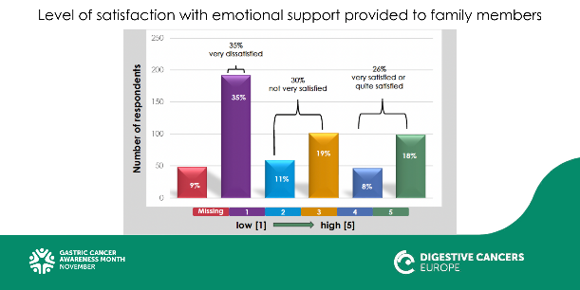
23/11 | How can we optimise the pathway of #patients with #GastricCancer? By implementing prevention practices across Europe, including early identification and treatment of #Hpylori. Find out more: bit.ly/3m2nbtB  #GastricCancerAwarenessMonth | It’s #GastricCancerAwarenessMonth. Today we’re asking:  How can we optimise the pathway of #patients with #GastricCancer?  By implementing prevention practices across Europe, including early identification and treatment of #Hpylori.  Find out more in our Roadmap: bit.ly/3m2nbtB
24/11 | Our survey of patients with #GastricCancer or oesophageal cancer showed that the three most frequent symptoms were: indigestion/gastric discomfort; gastric pains; trouble swallowing #GastricCancerAwarenessMonth bit.ly/3FpOtmz | It’s #GastricCancerAwarenessMonth. Our survey of patients with #GastricCancer or oesophageal cancer showed that the three most frequent symptoms were:  - Indigestion/gastric discomfort  - Gastric pains  - Trouble swallowing  Don’t ignore these symptoms! Talk to your family doctor if you, or someone you know, has them. Find out more: bit.ly/3CNi7A2  Please share further and help spread the word! Thank you so much #sharingiscaring bit.ly/3FpOtmz | 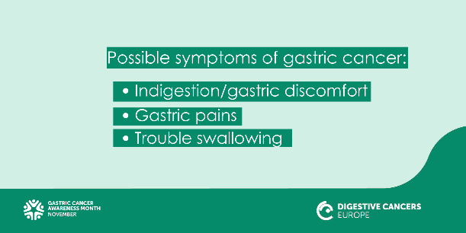
25/11 | Focusing on good nutrition can help #GastricCancer patients cope better and recover faster. Our dietary advice booklet is here to help: bit.ly/3iykK19  #GastricCancerAwarenessMonth | #GastricCancerAwarenessMonth daily fact for you to share!  Focusing on good nutrition can help #GastricCancer patients cope better and recover faster. Our dietary advice booklet is here to help: bit.ly/3iykK19 | 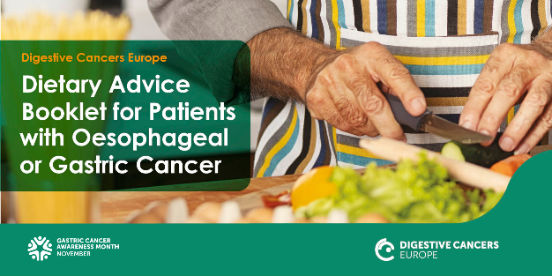
26/11 | We should invest in further research to allow for non-invasive mass screening for pre-cancer medical conditions that can lead to #GastricCancer. Read more bit.ly/3m2nbtB  #GastricCancerAwarenessMonth | We should Invest in further research which could allow non-invasive mass screening for pre-cancer medical conditions for #GastricCancer.  Read more about our recommendations in ‘The European Oesophageal and Gastric Cancers Roadmap’: bit.ly/3m2nbtB  #GastricCancerAwarenessMonth | 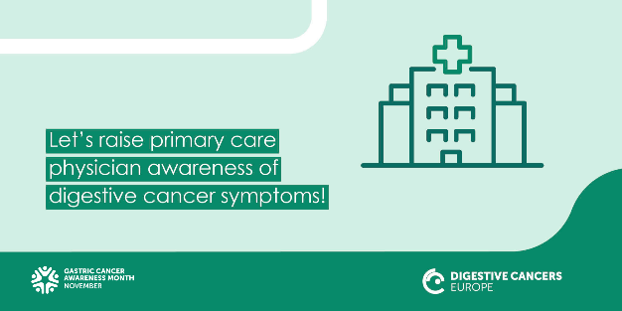
29/11 | We need to ensure the systematic referral of #GastricCancer patients to multidisciplinary, high-volume medical expert centres to improve patient outcomes and survival rates. Read more bit.ly/3m2nbtB  #GastricCancerAwarenessMonth | It’s #GastricCancerAwarenessMonth.  To help #GastricCancer patients, their outcomes and survival rates, we need to ensure the systematic referral of patients to multidisciplinary, high-volume medical expert centres.  Please discover more about this and our other recommendations in ‘The European Oesophageal and Gastric Cancers Roadmap’: bit.ly/3m2nbtB | 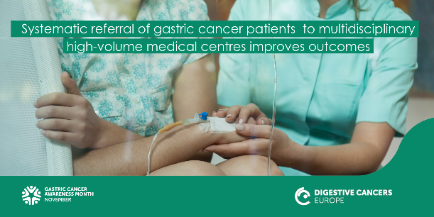
30/11 | Small, frequent meals help provide enough #nutrition to support recovery after #GastricCancer surgery. Discover more in our dietary booklet bit.ly/3iykK19  #GastricCancerAwarenessMonth | Small, frequent meals help provide enough #nutrition to support recovery after #GastricCancer surgery. Our dietary advice booklet is here to help people living with gastric cancer: bit.ly/3iykK19  Share our #GastricCancerAwarenessMonth fact and help patients with this lesser-known and difficult to treat digestive cancer. | 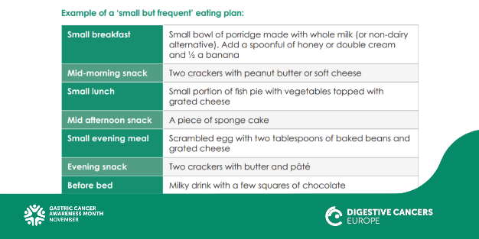
30/11 | Today marks the end of the #GastricCancerAwarenessMonth. We will continue to work and advocate for the best care and treatment for all patients with #GastricCancer across Europe. bit.ly/2WefCqL | Today marks the end of the #GastricCancerAwarenessMonth.  We will continue to work and advocate for the best care and treatment for all patients with #GastricCancer across Europe.  To stay informed about #GastricCancer beyond the month please see: bit.ly/2WefCqL | 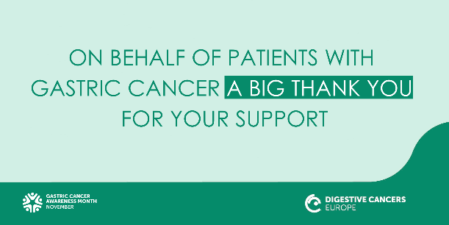
Below a list of our suggested @mentions to share in your posts where appropriate:
Organisation | Twitter Handle | Facebook Handle
Cancer Leagues | @CancerLeagues | @CancerLeagues
European Patients Forum | @EUPATIENTSFORUM | @EuropeanPatientsForum
ECPC | @cancereu | @ECPCfb
We Can | @WECANadvocate | @WECANadvocate
All Can | @AllCanGroup | @AllCanGroup
Data Save Lives | @datasaves_lives | @datasaveslives
European Cancer Organization | @europeancancer | @EuropeanCancer
European Alliance for Value in Health | @ValueInHealthEU | N/A
EASL | @EASLnews | @EASLnews
DiCE Member Organisation | Twitter Handle | Facebook Handle
Slovakia Nie Rakovine | @RakovineNie | @nierakovine
Bowel Cancer UK | @bowelcanceruk | @bowelcanceruk
EuropaColon Ukraine | @EuropaColonUkraine | @EuropaColonUkraine
The Oesophageal Patients Association | @opa_uk | @opa.org.uk
EuropaColon Belarus | @eurobelarusinfo | eurobelarus
EuropaColon Poland | @EuColonPolska | @EuropaColonPolska
Pasykaf Cyprus | @pasykaf_cy | @pasykaf
Onko Majak Czech republic | @Onkomajak | @onkomajak
Personal Colores (President Jenni Tamminen) | @tamminen_ry | N/A
Europacolon Italy | @EuropaColonITA | @europacolonitalia
Borka Macedonia | @borkaorg | N/A
Netherlands @StDarmkanker | @StDarmkanker | @stichtingdarmkanker
EuropaColon Spain | @europacolon_es | @europacolonespana
Colores | @colores_ry | @coloresry
Mon reseau colorectal director | @reseauKcolorect | @monreseaucancercolorectal
Dave Chuter | @OGCancerSupport | N/A
ACCGG | N/A | @informacion.accgg
Italian stomach | @viveresenzastom | N/A

