#LiverCancerAwarenessMonth Social Media Calendar

Thank you for taking part in this year’s #LiverCancerAwarenessMonth campaign. For the month of October, we will be posting the following on Twitter, Facebook and LinkedIn. We invite you to follow, like, share, retweet our posts or create your own from the suggested texts below.

If you would like to translate the texts on the images, we have also provided you with blank templates. If this is the case for your organisation, we ask you to please keep:
- Using our font Century Gothic
- The Digestive Cancers Europe logo on the images, adding your organisation’s logo in white alongside this in the orange border. This is important due to our ownership rights on the images.

If you need an easy-to-use application for updating the images, ‘Canva Pro’ is available free of charge for all NGOs and hence all our Members.
All images with and without texts are available here: https://bit.ly/3t7d2Pt
Should you have any questions on how to access the calendar or how to use Canva Pro, please contact catie@digestivecancers.eu.
Thanks again and we look forward to working on this important topic for European liver cancer patients together with you!

DATE. | Twitter Captions | Facebook/LinkedIn Captions | Visual
30/9 | #LiverCancerAwarenessMonth starts tomorrow! Help us raise awareness by keeping up with us, sharing or using our social media calendar: bit.ly/3yy2qKv | Did you know that #LiverCancerAwarenessMonth starts tomorrow? Help us save lives and improve the quality of life for those with liver cancer by keeping up with us, sharing or using our social media calendar – we’re stronger together in building awareness: bit.ly/3yy2qKv  Thanks so much! | 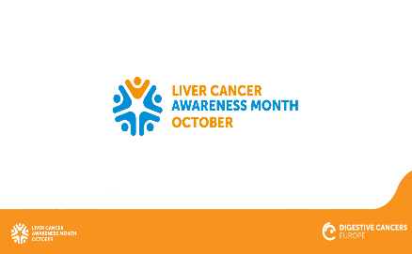
1/10 | It’s #LiverCancerAwarenessMonth. 2020 alone ≈88.000 new cases were diagnosed. Please share and help us raise awareness for people living with #LiverCancer  bit.ly/3yy2qKv | Our campaign for #LiverCancerAwarenessMonth starts today! Did you know that in 2020 alone ≈88.000 new cases of #LiverCancer were diagnosed? Please share and help us raise awareness for people living with liver cancer – helping to better their quality of life and save lives! bit.ly/3yy2qKv | 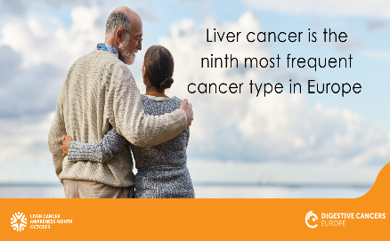
1/10 | It’s #LiverCancerAwarenessMonth please share our daily fact and help spread the word for patients! #sharingiscaring bit.ly/3yy2qKv | It’s #LiverCancerAwarenessMonth. We’re sharing a daily fact for the whole month – we hope you can share them further and help spread the word for patients! Thank you so much #sharingiscaring bit.ly/3yy2qKv | 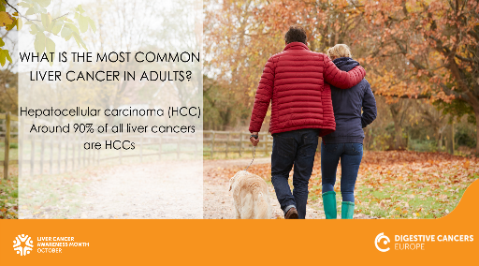
4/10 | What causes hepatocellular carcinoma, the most common form of #LiverCancer? bit.ly/3hXgbgN #LiverCancerAwarenessMonth #sharingiscaring for patients | What causes hepatocellular carcinoma, the most common form of #LiverCancer? Please share our daily fact and help raise awareness on this type of digestive cancer #LiverCancerAwarenessMonth #sharingiscaring for patients: bit.ly/3hXgbgN | 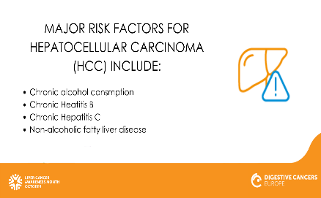
5/10 | Research shows that heavy alcohol consumption can cause #LiverCancer, #LiverCancerAwarenessMonth. Read more: bit.ly/3hXgbgN | Did you know research shows that heavy alcohol consumption can cause #LiverCancer – that’s why the adoption of healthy lifestyle can reduce the risk of liver cancer #LiverCancerAwarenessMonth. Read more: bit.ly/3hXgbgN | 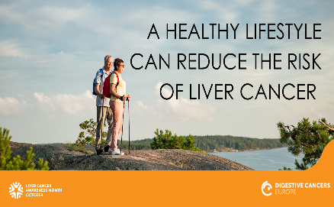
5/10 | How can we optimize the pathway of #patients with #LiverCancer? By Implementing prevention practices across Europe, including universal vaccination against the Hepatitis B virus and equitable access to treatment of Hepatitis C. #LiverCancerAwarenessMonth | How can we optimize the pathway of #patients with #LiverCancer? By implementing prevention practices across Europe, including universal vaccination against the Hepatitis B virus and equitable access to treatment of Hepatitis C. Share our daily fact and help save lives for #LiverCancerAwarenessMonth | 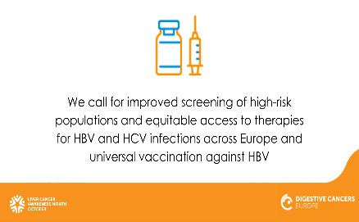
6/10 | Did you know that risk factors for #LiverCancer include alcohol, smoking and obesity? Read more: bit.ly/3hXgbgN #LiverCancerAwarenessMonth | It’s #LiverCancerAwarenessMonth. Did you know that there are several ways to reduce the risk of liver cancer? Share our daily fact, raise awareness and help save lives! Read more: bit.ly/3hXgbgN | 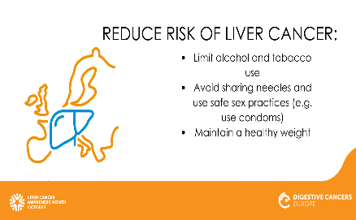
7/10 | What is the #liver? It’s an essential organ in the body with functions such as synthesis of plasma proteins and breaking down of toxins into safer forms. Take care of your liver and prevent #LiverCancer #LiverCancerAwarenessMonth bit.ly/3hXgbgN | What is the #liver? It’s an essential organ in the body with functions such as synthesis of plasma proteins and breaking down of toxins into safer forms. Take care of your liver and prevent #LiverCancer #LiverCancerAwarenessMonth bit.ly/3hXgbgN
8/10 | How can we optimize the pathway of #patients with #LiverCancer? Promote the application of harmonized guidelines. Register for our event and find out more: us06web.zoom.us/j/94814436243 #LiverCancerAwarenessMonth | Optimizing the pathway of #patients with #LiverCancer is essential in our view. How can this be done? By promoting the application of harmonized guidelines. Register for our event here and find out more: us06web.zoom.us/j/94814436243 #LiverCancerAwarenessMonth | 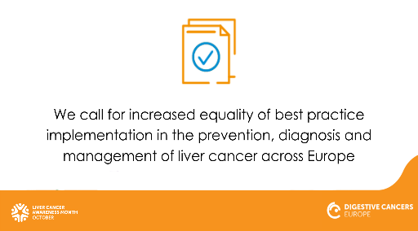
9/10 | Did you know that Europe has the largest burden of liver disease in the world? In the coming years this is expected to grow across many countries bit.ly/3hXgbgN #LiverCancer. #LiverCancerAwarenessMonth | It’s #LiverCancerAwarenessMonth, did you know that Europe has the largest burden of liver disease in the world? In the coming years this is expected to grow across many countries. It’s important if you have a family history of #LiverCancer to talk with your doctor. bit.ly/3hXgbgN | 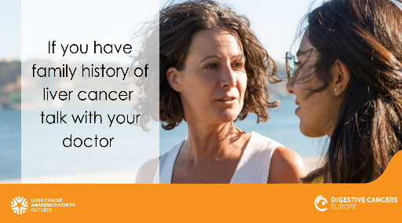
11/10 | October 26 we will launch our White Paper, Liver Cancer: No Patient Left Behind together with @EuropeLiver. Register today and get the full story on this important topic: us06web.zoom.us/j/94814436243 #LiverCancerAwarenessMonth | We are proud to be launching our White Paper, Liver Cancer: No Patient Left Behind during #LiverCancerAwarenessMonth. We invite you to join us on October 26 at our event exploring #LiverCancer and the path to better patient care together with our partner @EuropeLiver. Register today: us06web.zoom.us/j/94814436243 | 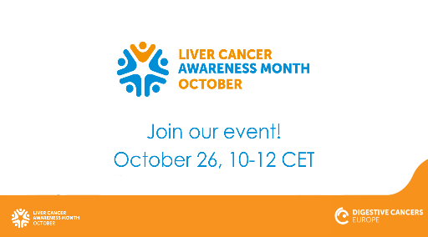
12/10 | Did you know that #LiverCancer is the ninth most frequent cancer type in Europe? ≈88.000 new cases were diagnosed in 2020 and case numbers are projected to increase. Read more about the cost (impact/burden) in our Health Economics factsheet here: bit.ly/3yzriBF #LiverCancerAwarenessMonth | Did you know that #LiverCancer is the ninth most frequent cancer type in Europe? ≈88.000 new cases were diagnosed in 2020 and case numbers are projected to increase. Read more about the cost (impact/burden) in our Health Economics factsheet here: bit.ly/3yzriBF #LiverCancerAwarenessMonth | 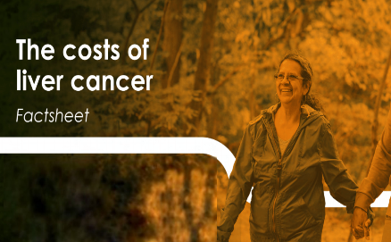
12/10 | Ensure the systematic referral of liver cancer patients to multi-disciplinary, high-volume medical expert centres to improve patient outcomes and survival rates.  For more info: bit.ly/3DzCVfF  #LiverCancerAwarenessMonth | It’s #LiverCancerAwarenessMonth! The question of the day is: How can we improve #patient outcomes and survival rates? It’s important to ensure the systematic referral of #LiverCancer patients to multi-disciplinary, high-volume medical expert centres. For more info: bit.ly/3DzCVfF | 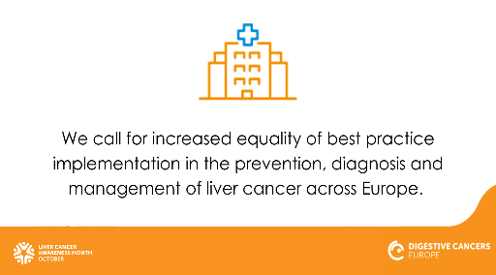
13/10 | #LiverCancer is the seventh most common cancer-related cause of death, accounting for ≈78.400 deaths per year in Europe. Please share further #LiverCancerAwarenessMonth  bit.ly/3yzriBF | Did you know that #LiverCancer is the seventh most common cancer-related cause of death In Europe? It accounts for ≈78.400 deaths per year. By raising awareness we’re working to reduce the number of people impacted by liver cancer, please keep on sharing for #LiverCancerAwarenessMonth #sharingiscaring bit.ly/3yzriBF | 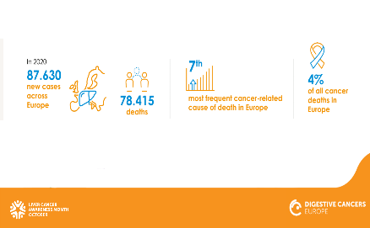
14/10 | Did you know that the economic burden of #LiverCancer is ≈€4 billion each year in Europe, of which ≈€1.2 billion relates to direct costs?  bit.ly/3yzriBF  #LiverCancerAwarenessMonth | Did you know that the economic burden of #LiverCancer is ≈€4 billion each year in Europe, of which ≈€1.2 billion relates to direct costs? Find more important data to use and share during #LiverCancerAwarenessMonth from our factsheet: bit.ly/3yzriBF | 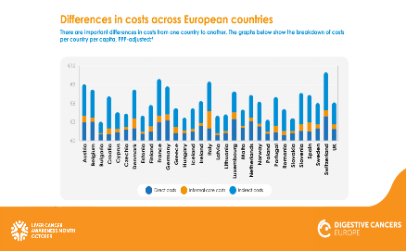
15/10 | #LiverCancer fact: hepatocellular carcinoma patients usually have another liver disease, and possible co-morbidities, meaning multi-disciplinary care is essential!  bit.ly/3DzCVfF  #LiverCancerAwarenessMonth | It’s #LiverCancerAwarenessMonth and our #LiverCancer fact for today: hepatocellular carcinoma (HCC) patients usually are living with another liver disease, and possible co-morbidities, meaning multi-disciplinary care is essential!  Please share and help spread awareness: bit.ly/3DzCVfF | 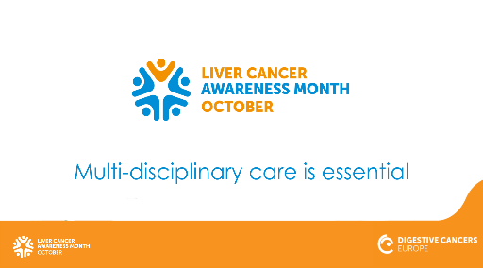
18/10 | Several risk factors associated with #LiverCancer are related to lifestyle, so many cases of the most common liver cancer - hepatocellular carcinoma - are preventable. bit.ly/3hXgbgN #LiverCancerAwarenessMonth | Did you know that several risk factors associated with #LiverCancer are related to lifestyle? So, many cases of the most common liver cancer - hepatocellular carcinoma (HCC) - are preventable. During #LiverCancerAwarenessMonth we will be sharing useful material to help spread awareness, join us! #sharingiscaring bit.ly/3hXgbgN | 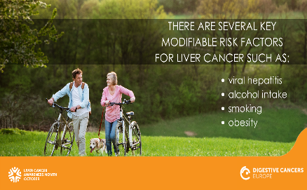
19/10 | Early diagnosis for liver cancer is challenging. That is because signs and symptoms often do not appear until it is in its later stages. bit.ly/3hXgbgN #LiverCancerAwarenessMonth | Early diagnosis for #LiverCancer is challenging. That is because signs and symptoms often do not appear until it’s in its later stages. It’s important to invest in primary prevention and citizen education for better lifestyle choices against #LiverCancer bit.ly/3hXgbgN. Please share further during #LiverCancerAwarenessMonth | 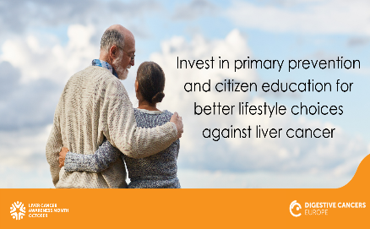
20/10 | #LiverCancer carries negative social connotations. Everyone should be supported; no one should be left behind. bit.ly/3DzCVfF  #LiverCancerAwarenessMonth | #LiverCancer carries negative social connotations. Everyone should be supported; no one should be left behind.  During #LiverCancerAwarenessMonth help us spread awareness and fight stereotypes surrounding bit.ly/3DzCVfF | 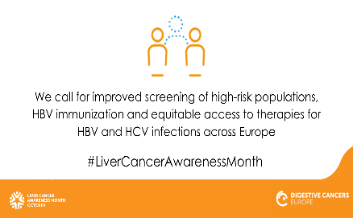
21/10 | Key modifiable risk factors for #LiverCancer include viral #hepatitis, heavy alcohol intake, smoking and obesity. Read more: bit.ly/3hXgbgN #LiverCancerAwarenessMonth | As many as half of #LiverCancer cases are preventable! Some key modifiable risk factors include: viral #hepatitis, heavy alcohol intake, smoking and obesity. Share our daily fact to help save lives. Read more here: bit.ly/3hXgbgN #LiverCancerAwarenessMonth | 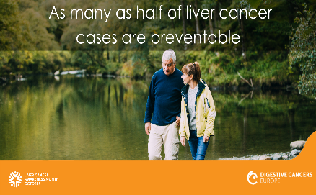
22/10 | #LiverCancer screening programmes in most countries are unavailable. It’s important that people at high risk are aware of the symptoms so they can get an early-stage diagnosis. Read more: bit.ly/3hXgbgN #LiverCancerAwarenessMonth | #LiverCancer screening programmes in most countries are unavailable. It’s important that people at high risk are aware of the symptoms so they can get an early-stage diagnosis. Read more: bit.ly/3hXgbgN and share further for #LiverCancerAwarenessMonth | 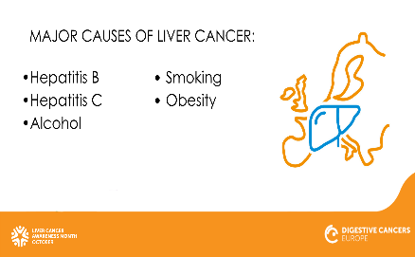
24/10 | Know your #LiverCancer symptoms,  and talk to your doctor. It’s preventable! Read more: bit.ly/3hXgbgN  #LiverCancerAwarenessMonth | It’s important to know your #LiverCancer symptoms, and talk to your doctor about them should they occur.  Please share our daily #LiverCancerAwarenessMonth fact and help reduce the burden of this digestive cancer.  Read more here: bit.ly/3hXgbgN | 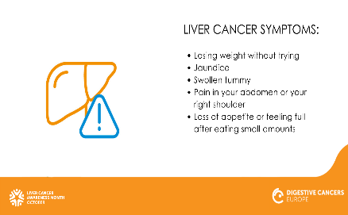
25/10 | If you have a family history of #LiverCancer or other risk factors, talk to your doctor to monitor or reduce your risk digestivecancers.eu/liver-cancer-risk-factors/ #LiverCancerAwarenessMonth | If you have a family history of #LiverCancer or other risk factors, talk to your doctor to monitor or reduce your risk. If you know someone who could be touched by this disease, please share further, it could save their life! digestivecancers.eu/liver-cancer-risk-factors/ #LiverCancerAwarenessMonth | 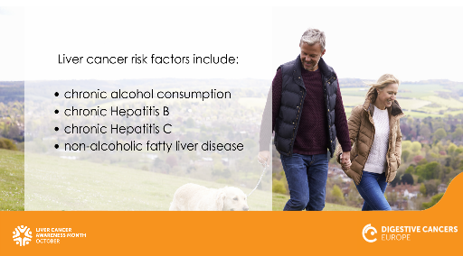
26/10. | Today we launched our #LiverCancer White Paper at our joint event with @EuropeLiver. Find key information and data regarding liver cancer in Europe: bit.ly/3DzCVfF #LiverCancerAwarenessMonth | Today we launched our #LiverCancer White Paper, Liver Cancer: No Patient Left Behind, at our joint event with @EuropeLiver. Find key information and data regarding liver cancer in Europe: bit.ly/3DzCVfF  #LiverCancerAwarenessMonth | Image available end-September – will be updated via Dropbox link
26/10 | #LiverCancer early symptoms are non-specific and can include: a swollen tummy, pain in the abdomen or right shoulder and feeling sick. Read more: bit.ly/3hXgbgN #LiverCancerAwarenessMonth | It’s #LiverCancerAwarenessMonth and it’s important to know the early symptoms of #LiverCancer. They are non-specific and can include: a swollen tummy, loss of appetite, losing weight without trying, pain in the abdomen or right shoulder and feeling sick. Read more: bit.ly/3hXgbgN and please share this post further – it could save someone’s life!
27/10 | We call for increased equality of best practice implementation in the prevention, diagnosis and management of #LiverCancer across Europe. Read more: bit.ly/3DzCVfF  #LiverCancerAwarenessMonth | We call for increased equality of best practice implementation in the prevention, diagnosis and management of #LiverCancer for patients across Europe. Read more: bit.ly/3DzCVfF  #LiverCancerAwarenessMonth
27/10 | #LiverCancer is the fifth most costly digestive cancer: liver cancer today costs ≈€4 billion in Europe. Read more: bit.ly/3yzriBF  #LiverCancerAwarenessMonth | Did you know that #LiverCancer is the fifth most costly digestive cancer: today liver cancer costs ≈€4 billion in Europe. Read more:  bit.ly/3yzriBF and please share further for #LiverCancerAwarenessMonth | 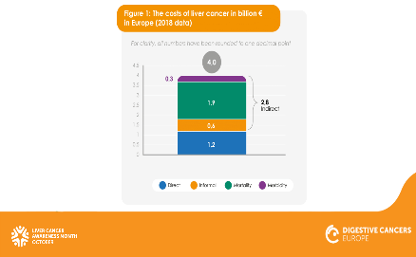
28/10 | Ways to prevent #LiverCancer include: limiting the use of alcohol and tobacco, safe sex practices and avoiding sharing needles. Read more: bit.ly/3hXgbgN #LiverCancerAwarenessMonth | It’s #LiverCancerAwarenessMonth and it’s important to know how to prevent it. These include: limiting the use of alcohol and tobacco, safe sex practices and avoiding sharing needles. Please share this post further and help others understand better how to stay safe and healthy. Read more: bit.ly/3hXgbgN | 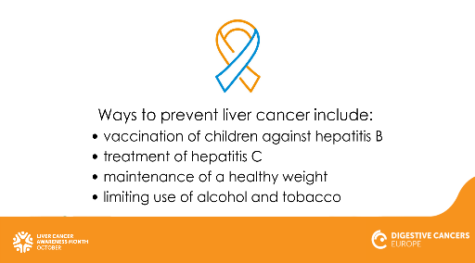
29/10 | We need to ensure #LiverCancer research incorporates the #patient perspective and #patientvoice. Read more: bit.ly/3DzCVfF  #LiverCancerAwarenessMonth | For #LiverCancerAwarenessMonth and beyond we need to ensure #LiverCancer research incorporates the #patient perspective and #patientvoice. Find out more in our White Paper, Liver Cancer: No Patient Left Behind, launched this month: bit.ly/3DzCVfF
31/10 | Today marks the end of the #LiverCancerAwarenessMonth. We will continue to work and advocate for the best care and treatment for all patients with #LiverCancer across Europe. bit.ly/3hXgbgN | Today marks the end of the #LiverCancerAwarenessMonth. We will continue to work and advocate for the best care and treatment for all patients with #LiverCancer across Europe. Thank you to everybody for your help in spreading awareness – for the month and beyond! With this we are helping to save lives and improve the quality of life for those with liver cancer. bit.ly/3hXgbgN | 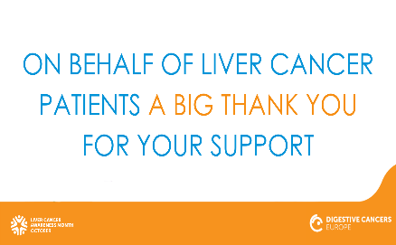

Below a list of our suggested @mentions to share in your posts where appropriate:
Organisation | Twitter Handle | Facebook Handle
European Liver Patients Association | @EuropeLiver | @EuropeLiver
Cancer Leagues | @CancerLeagues | @CancerLeagues
European Patients Forum | @EUPATIENTSFORUM | @EuropeanPatientsForum
ECPC | @cancereu | @ECPCfb
We Can | @WECANadvocate | @WECANadvocate
All Can | @AllCanGroup | @AllCanGroup
Data Save Lives | @datasaves_lives | @datasaveslives
European Cancer Organization | @europeancancer | @EuropeanCancer
European Alliance for Value in Health | @ValueInHealthEU | N/A
EASL | @EASLnews | @EASLnews
World Hepatitis Alliance | @Hep_Alliance | @worldhepalliance
Hepatitis Central | @HepCentral | @Hepatitis-Central-52852867067
The Hepatitis C Trust | @HepatitisCTrust | @HepatitisCTrust
The International Liver Cancer Association | @ILCAnews | @InternationalLiverCancerAssociation

